Module – 1(Lab Exercise)

Q: Write a simple "Hello World" program in two different programming languages of your choice. Compare the structure and syntax.
A: python:
print("Hello, World!")
A: java:
public class HelloWorld {
public static void main(String[] args) {
System.out.println("Hello, World!");
}
}

Q: Research and create a diagram of how data is transmitted from a client to a server over the internet.
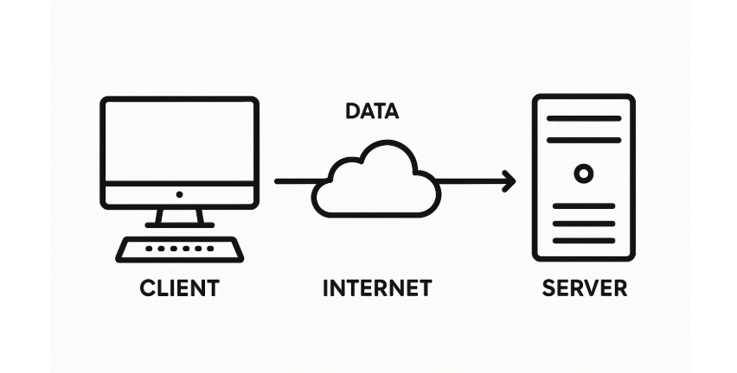

Q: Design a simple HTTP client-server communication in any language.

Q: Research different types of internet connections (e.g., broadband, fiber, satellite) and list their pros and cons.
A: 1. Broadband (DSL / Cable Connection)
Broadband internet is commonly provided through DSL (via telephone lines) or Cable (via TV cables). It's one of the most widely used types of internet.
Pros: It's affordable, always on, and available in most urban and semi-urban areas.
Cons: DSL speed depends on your distance from the provider, and in cable connections, speed may drop during peak hours due to shared bandwidth.

2. Fiber Optic Internet
Fiber internet uses fiber-optic cables that transmit data as light signals, offering very high-speed internet.
Pros: It provides extremely fast speeds, low latency, and high reliability, ideal for streaming, gaming, and business use.
Cons: It is expensive to install and may not be available in all areas, especially rural ones.

3. Satellite Internet
This type of internet is provided through satellites orbiting the Earth, making it accessible even in remote locations.
Pros: It's available almost everywhere, including rural and remote areas, without the need for cables.
Cons: It has high latency, can be affected by weather conditions, and data plans are often expensive.

Q: Simulate HTTP and FTP requests using command line tools (e.g., curl).
A: HTTP request simulation using curl:
curl http://example.com
A: FTP request simulation using curl:
curl ftp://speedtest.tele2.net/1KB.zip -o 1KB.zip

Q: Identify and explain three common application security vulnerabilities.

Q: Identify and classify 5 applications you use daily as either system software or application software.
A:
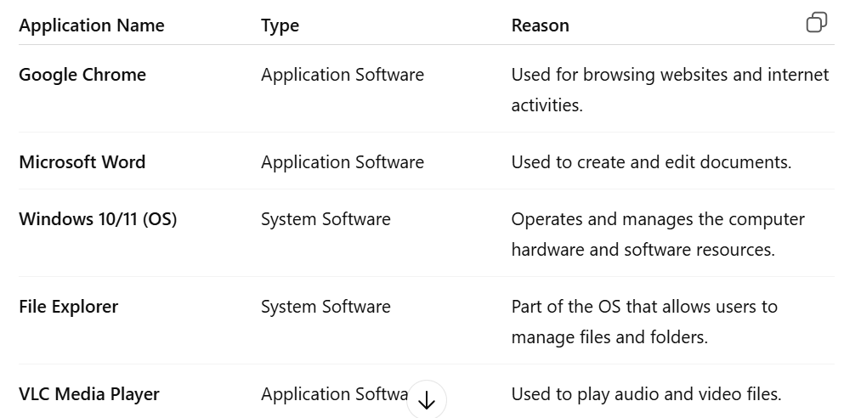

Q: Design a basic three-tier software architecture diagram for a web application.
A:
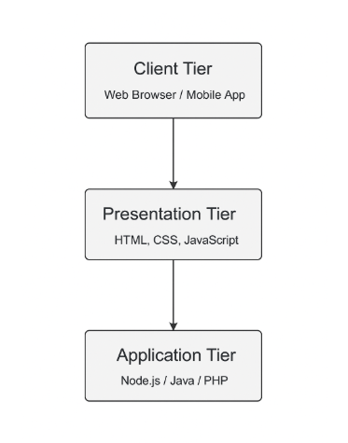

Q: Create a case study on the functionality of the presentation, business logic, and data access layers of a given software system.

Q: Explore different types of software environments (development, testing, production). Set up a basic environment in a virtual machine.

Q: Write and upload your first source code file to Github.
A:Let’s write a simple program.
Example: hello.py in Python

Python
# hello.py
print("Hello, GitHub!")

Q: Create a Github repository and document how to commit and push code changes.

Q: Create a student account on Github and collaborate on a small project with a classmate.

Q: Create a list of software you use regularly and classify them into the following categories: system, application, and utility software.
A:System software:-
->Under System Software, I mainly use Windows 11 or sometimes Linux as the operating system, which is responsible for running and managing the entire computer. I also use printer drivers, which are essential for connecting and operating printers with the system.
A:Application software:-
-> In the category of Application Software, I use Microsoft Word for creating and editing documents, and Google Chrome for browsing the internet. To play audio and video files, I use VLC Media Player. For managing accounts and business tasks, Tally ERP is very helpful. I also use Notepad++ for writing code and taking notes, and MySQL or Oracle for database management work.
A:Utility software:-
-> As for Utility Software, I use Quick Heal Antivirus to protect my computer from viruses and threats. To compress or extract files, I use tools like WinRAR or 7-Zip. I also use Disk Cleanup to free up space on the hard drive and Task Manager to monitor system performance and running processes.

Q: Follow a GIT tutorial to practice cloning, branching, and merging repositories.

Q: Write a report on the various types of application software and how they improve productivity.
1. Word Processing Software
Examples: Microsoft Word, Google Docs, LibreOffice Writer
Purpose: Create, edit, and format text-based documents.
Productivity Benefits:
Enables fast typing and editing.
Spell-check and grammar tools reduce errors.
Templates save time on repeated tasks.

2. Spreadsheet Software
Examples: Microsoft Excel, Google Sheets
Purpose: Perform calculations, analyze data, and create charts.
Productivity Benefits:
Automates mathematical operations and financial reports.
Offers data visualization tools for better decision-making.
Built-in functions (like SUM, IF, VLOOKUP) save time.

3. Presentation Software
Examples: Microsoft PowerPoint, Google Slides
Purpose: Design and deliver visual presentations.
Productivity Benefits:
Helps convey ideas clearly and visually.
Allows team collaboration and easy sharing.
Saves time with pre-designed templates.

4. Database Management Software (DBMS)
Examples: Microsoft Access, MySQL, Oracle DB
Purpose: Store, manage, and retrieve structured data.
Productivity Benefits:
Centralized data access reduces redundancy.
Fast retrieval and filtering of data.
Supports data consistency and security.

5. Graphics and Design Software
Examples: Adobe Photoshop, CorelDRAW, Canva
Purpose: Create and edit images, illustrations, and designs.
Productivity Benefits:
Enhances creativity and branding.
Templates and presets improve design speed.
Streamlines marketing and content creation.

6. Communication Software
Examples: Zoom, Microsoft Teams, Slack, Gmail
Purpose: Facilitate messaging, video calls, and collaboration.
Productivity Benefits:
Enables remote work and virtual meetings.
Real-time collaboration improves teamwork.
Reduces delays in project execution.

7. Web Browsers
Examples: Google Chrome, Mozilla Firefox, Microsoft Edge
Purpose: Access and interact with information on the internet.
Productivity Benefits:
Access to research, tools, and cloud apps.
Extensions increase efficiency (e.g., grammar checkers, timers).
Supports web-based project management and learning.

8. Project Management Software
Examples: Trello, Asana, Microsoft Project
Purpose: Plan, track, and manage tasks and timelines.
Productivity Benefits:
Keeps teams organized and on schedule.
Tracks deadlines, responsibilities, and progress.
Promotes accountability and better workflow.

9. Accounting and Finance Software
Examples: Tally, QuickBooks, Zoho Books
Purpose: Manage billing, payroll, budgeting, and financial records.
Productivity Benefits:
Reduces manual calculations and errors.
Generates instant financial reports.
Saves time on tax and payroll processing.

Q: Create a flowchart representing the Software Development Life Cycle (SDLC).
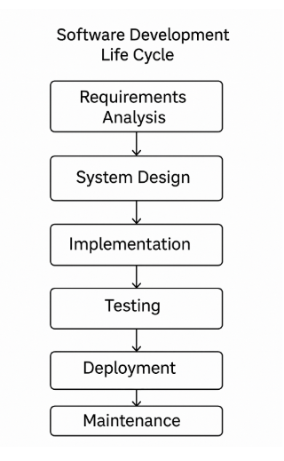

Q: Write a requirement specification for a simple library management system.
A:
1 Book Management
- Add new books with details (Title, Author, ISBN, Quantity).
- Edit or delete book records.
- View list of all available books.
2 Member Management
- Add new members (name, ID, contact).
- Edit or delete member information.
3 Book Issuing
- Issue books to registered members.
- Update book quantity after issue.
- Record issue date and due date.
4 Book Return
- Accept returned books.
- Update book stock.
- Calculate and apply fine if return is late.
5 Search and Filter
- Search for books by title, author, or ISBN.
- Filter available and issued books.
6 Reports
- Generate reports of issued books, returned books, fines collected, etc.

Q: Perform a functional analysis for an online shopping system.
A: 1. User Registration & Login
- Users system me register karte hain.
- Login karne ke baad apna account access karte hain.
2. Product Catalog
- Products categories me divide hote hain (Clothing, Electronics, etc.).
- Har product ke details dikhte hain: naam, price, image, description.
3. Search & Filter
- User products search kar sakta hai.
- Price, brand, rating ke basis par filter kar sakta hai.
4. Shopping Cart
- Users items cart me add karte hain.
- Quantity badha/ghata sakte hain.
- Total price show hota hai.
5. Checkout & Payment
- User address dalta hai.
- Payment karta hai (UPI, debit card, etc.).
- Order confirm hota hai.
6. Order Tracking
- Order placed hone ke baad tracking details milti hain.
- Delivery status update hota hai.
7. User Feedback/Reviews
- Users product ke reviews likh sakte hain.
- Ratings de sakte hain.
8. Admin Panel
- Admin products add/update/delete karta hai.
- Orders manage karta hai.
- Users ko monitor karta hai.

Q: Design a basic system architecture for a food delivery app.
A:
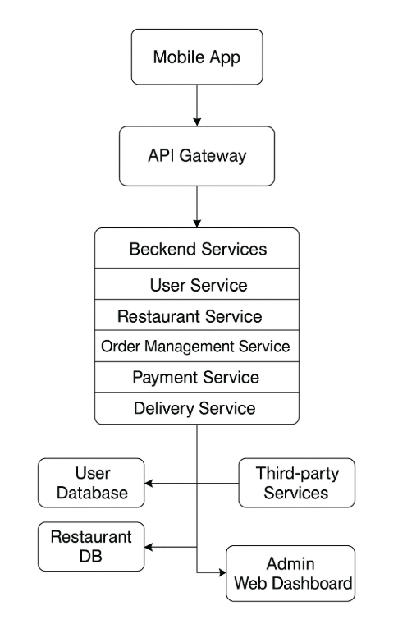

Q: Develop test cases for a simple calculator program.
A:
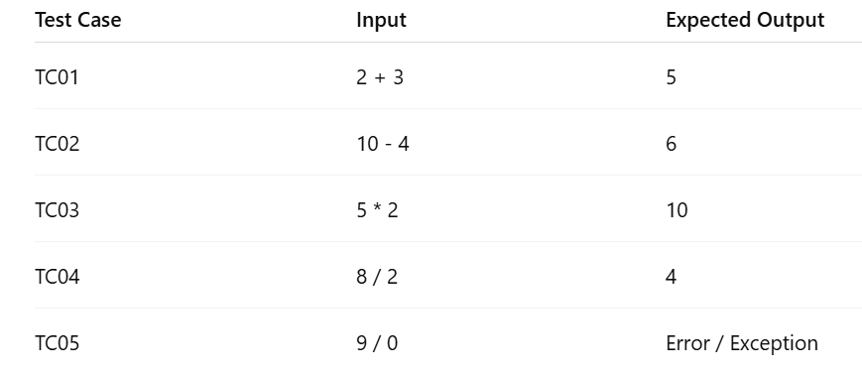

Q: Document a real-world case where a software application required critical maintenance.
A: Case Study: Facebook Outage – October 4, 2021
Overview:
On October 4, 2021, Facebook and its related services — Instagram, WhatsApp, and Messenger — were down globally for over 6 hours. This was one of the most severe outages in the company’s history and required urgent software and network maintenance to restore services.
Q: Create a DFD for a hospital management system.
A: Hospital management system: 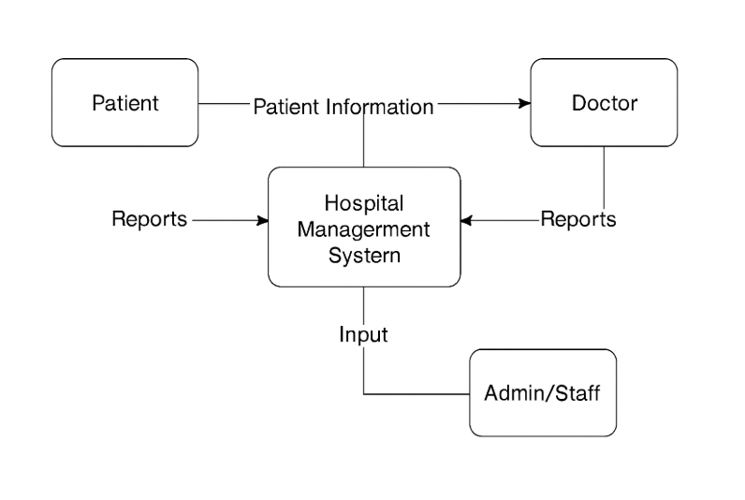

Q: Build a simple desktop calculator application using a GUI library.
A: simple desktop calculator using python gui:-
- import tkinter as tk

- def click(event):
- text = event.widget.cget("text")
- if text == "=":
- try:
- result = eval(str(entry.get()))
- entry.delete(0, tk.END)
- entry.insert(tk.END, str(result))
- except Exception as e:
- entry.delete(0, tk.END)
- entry.insert(tk.END, "Error")
- elif text == "C":
- entry.delete(0, tk.END)
- else:
- entry.insert(tk.END, text)

- # Create main window
- root = tk.Tk()
- root.title("Simple Calculator")
- root.geometry("300x400")

- # Entry box
- entry = tk.Entry(root, font="Arial 20")
- entry.pack(fill=tk.BOTH, ipadx=8, pady=10, padx=10)

- # Button layout
- buttons = [
- ["7", "8", "9", "/"],
- ["4", "5", "6", "*"],
- ["1", "2", "3", "-"],
- ["C", "0", "=", "+"]
- ]

- # Create buttons in grid
- for row in buttons:
- frame = tk.Frame(root)
- frame.pack()
- for btn in row:
- b = tk.Button(frame, text=btn, font="Arial 18", width=5, height=2)
- b.pack(side=tk.LEFT, padx=5, pady=5)
- b.bind("<Button-1>", click)

- # Run the application
- root.mainloop()

Q: Draw a flowchart representing the logic of a basic online registration system.
A: Basic online registration system:
